Batch: A2 Roll No.: 16010122034

Experiment No. 5

TITLE: Implementation of IEEE-754 floating point representation

AIM: To demonstrate the single and double precision formats to represent floating point numbers.
______________________________________________________________________
Expected OUTCOME of Experiment: (Mention CO attained here)
CO1- Describe and define the structure of a computer with buses structure and detail working
of the arithmetic logic unit and its sub modules
___________________________________________________________________
Books/ Journals/ Websites referred:
- Carl Hamacher, Zvonko Vranesic and Safwat Zaky, “Computer Organization”, Fifth Edition, TataMcGraw-Hill.
- William Stallings, “Computer Organization and Architecture: Designing for Performance”, Eighth Edition, Pearson.
_____________________________________________________________________
Pre Lab/ Prior Concepts:
The IEEE Standard for Floating-Point Arithmetic (IEEE 754) is a technical standard for floating-point computation established in 1985 by the Institute of Electrical and Electronics Engineers (IEEE). The standard addressed many problems found in the diverse floating point implementations that made them difficult to use reliably and portably. Many hardware floating point units now use the IEEE 754 standard.
The standard defines:
- arithmetic formats: sets of binary and decimal floating-point data, which consist of finite numbers (including signed zeros and subnormal numbers), infinities, and special "not a number" values (NaNs)
- interchange formats: encodings (bit strings) that may be used to exchange floating-point data in an efficient and compact form
- rounding rules: properties to be satisfied when rounding numbers during arithmetic and conversions
- operations: arithmetic and other operations (such as trigonometric functions) on arithmetic formats
- exception handling: indications of exceptional conditions (such as division by zero, overflow, etc

Example
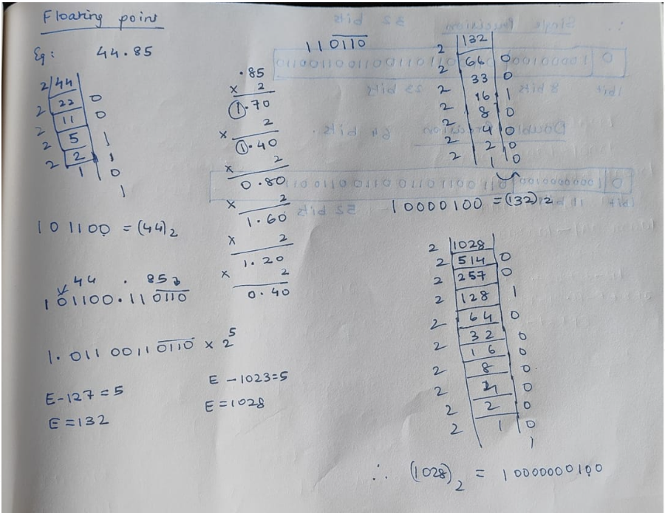

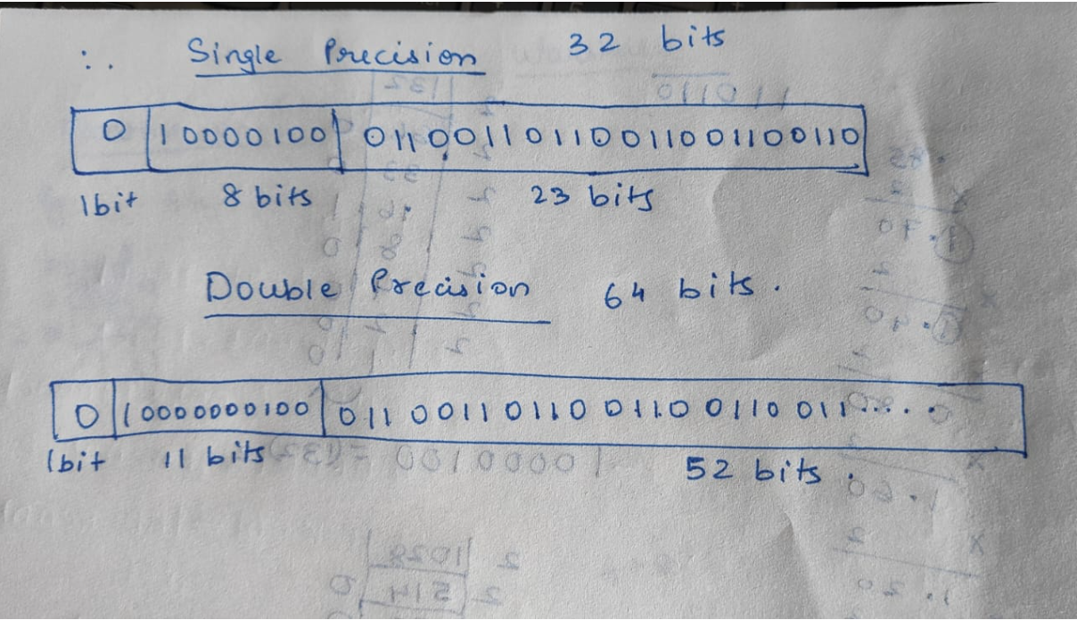

CODE:

OUTPUT:
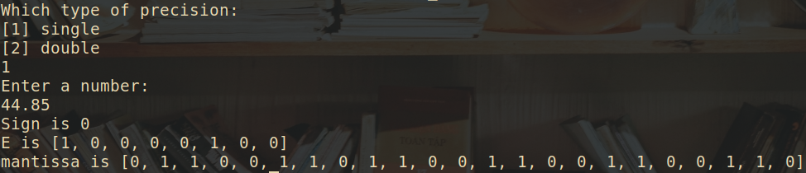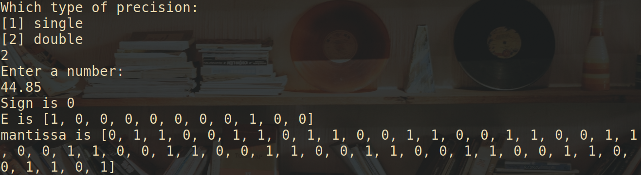

Post Lab Descriptive Questions
Give the importance of IEEE-754 representation for floating point numbers

ANS:
- The IEEE Standard for Floating-Point Arithmetic (IEEE 754) is a technical standard for floating-point computation which was established in 1985 by the Institute of Electrical and Electronics Engineers (IEEE).
- The standard addressed many problems found in the diverse floating point implementations that made them difficult to use reliably and reduced their portability. IEEE Standard 754 floating point is the most common representation today for real numbers on computers, including Intel-based PC’s, Macs, and most Unix platforms.
- There are several ways to represent floating point number but IEEE 754 is the most efficient in most cases.

Conclusion
The code for single and double precision formats to represent floating point numbers was executed successfully.

Date: _____________

